5th Grade School Supply List

* **4** glue sticks
* **2** 24-pack pencils
* **3** packages of lined paper
* 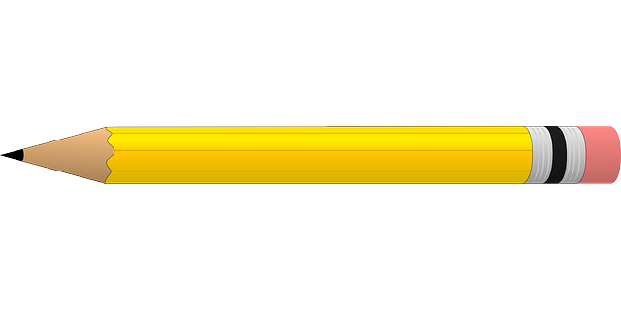**1** 2-inch binder *with cover sleeve
* **3** composition notebooks
* **3** folders with prongs (1 blue, 1 green, 1 choice color)
* Headphones or earbuds (must be wired or USB plug)
* Scissors
* **2+** Tissues
* Clorox Wipes
* **1** box each: crayons and colored pencils
* **Girls**: sandwich Ziploc bags & hand soap
* **Boys**: quart or gallon Ziploc bags & hand sanitizer
* Shareable HEALTHY snacks

(fruit snacks, crackers, goldfish, cereal, etc.)

*NO pencil sharpeners! Thank you.